**CLOUD COMPUTING LAB EXPERIMENTS**

**EX NO. : 1**

# Install Virtualbox/VMware Workstation with different flavours of linux or windows OS on top of windows11.

**Aim:** To Install Virtualbox / VMware Workstation with different flavours of linux or windows OS on top of windows7 or 8.

# PROCEDURE:

**Steps to install Virtual Box:**

1. Download the Virtual box exe and click the exe file…and select next button.

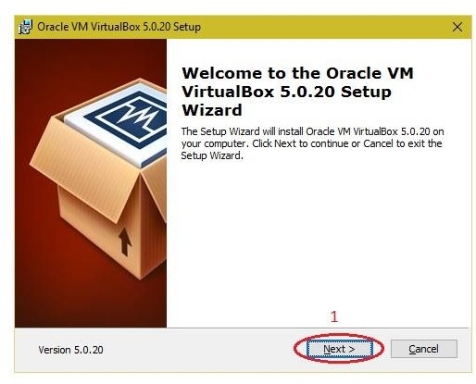

1. Click the next button.

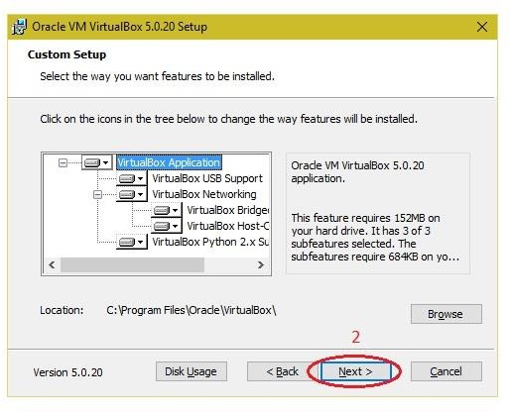

1. Click the next button

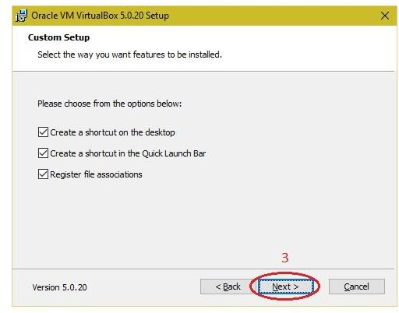

1. Click the YES button.

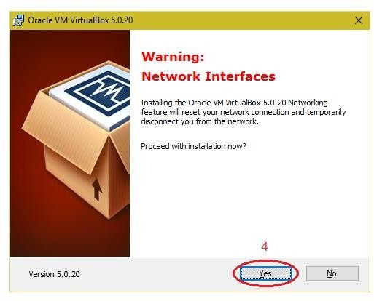

5, Click the install button

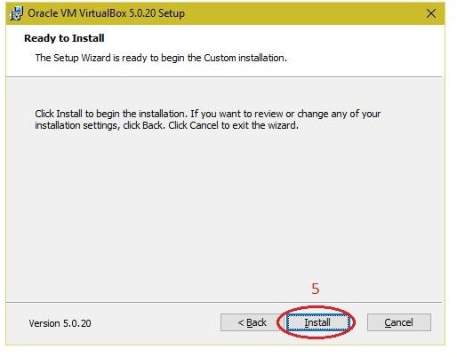

1. Then installation was completed. The VirtualBox icon will be shown on the desktop screen….

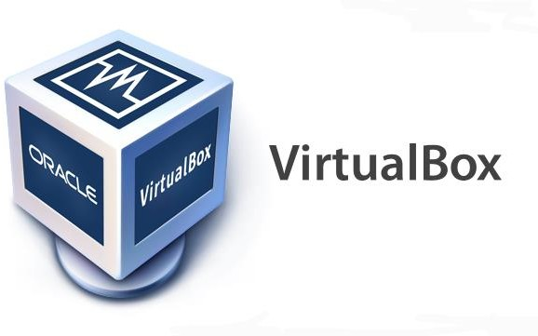

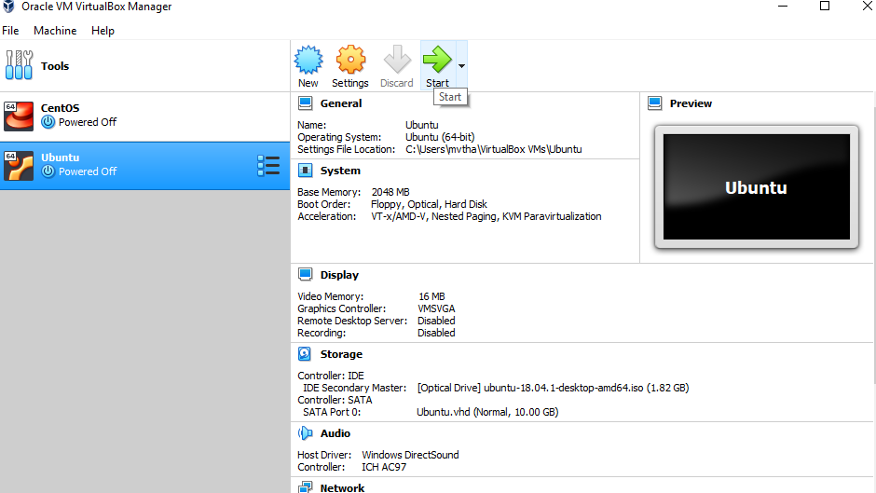

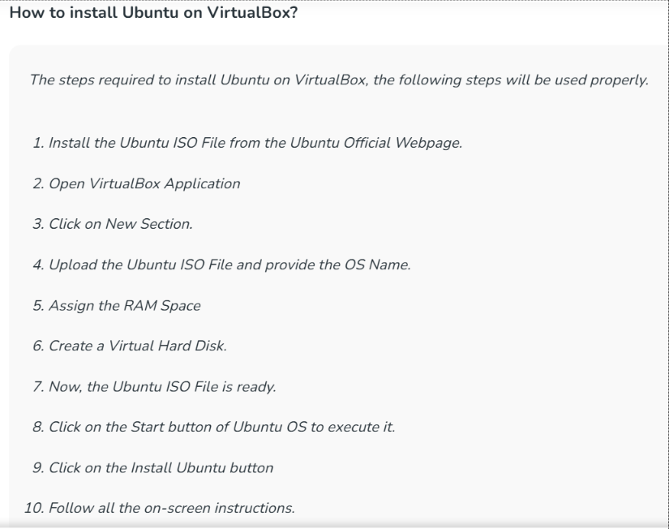

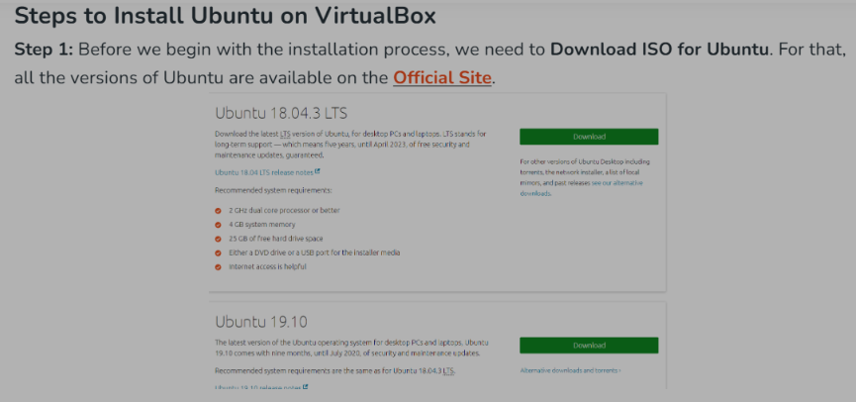

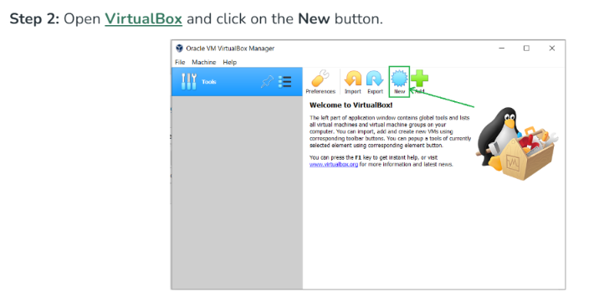

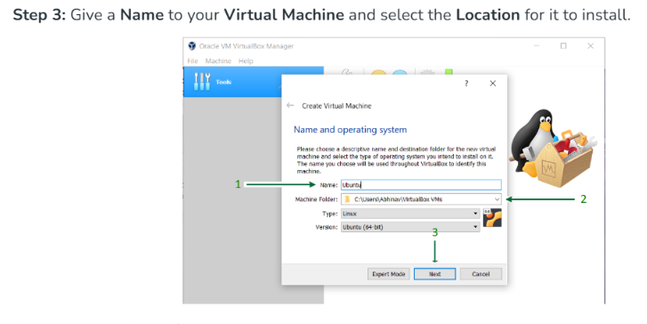

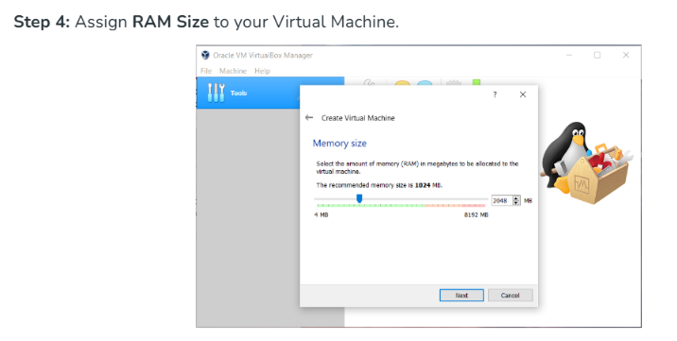

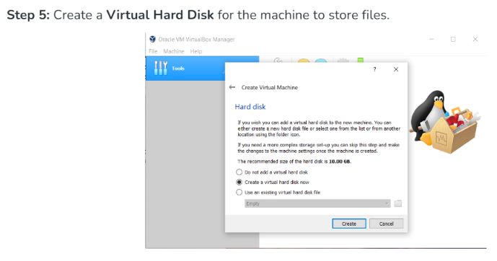

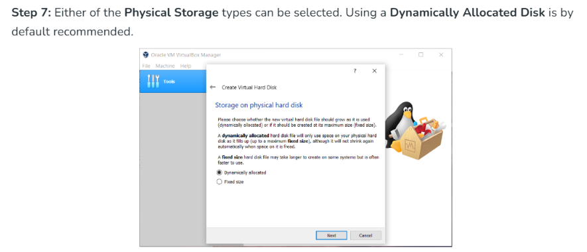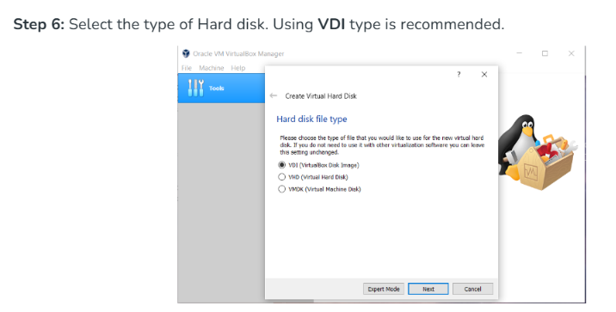

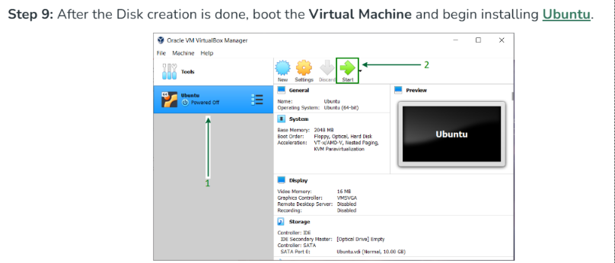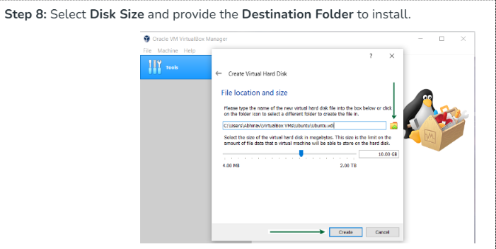

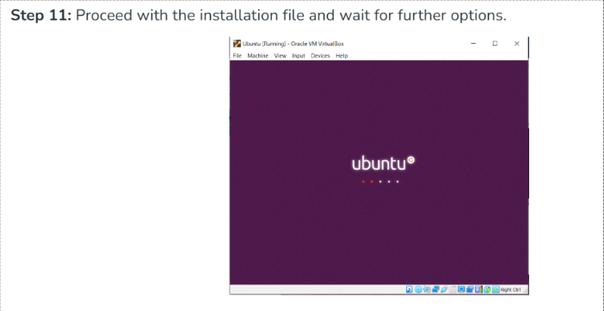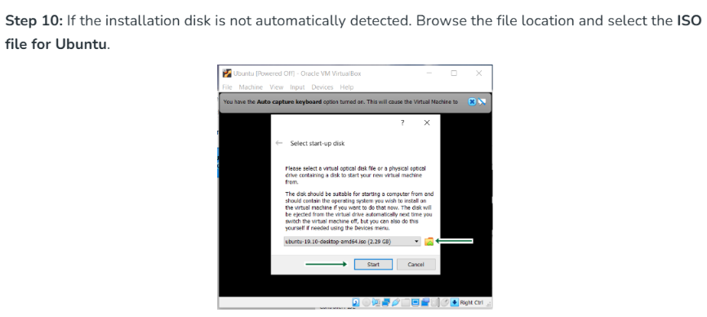

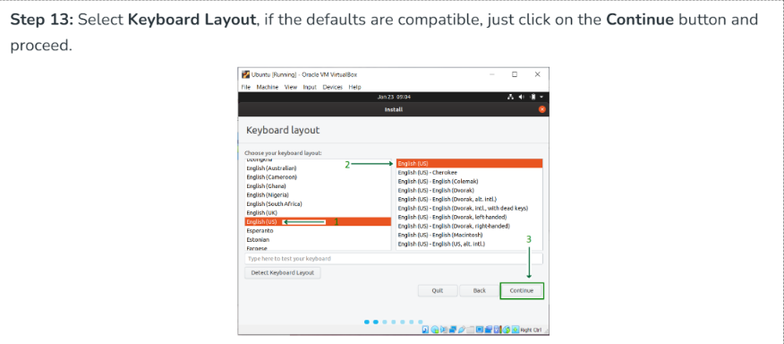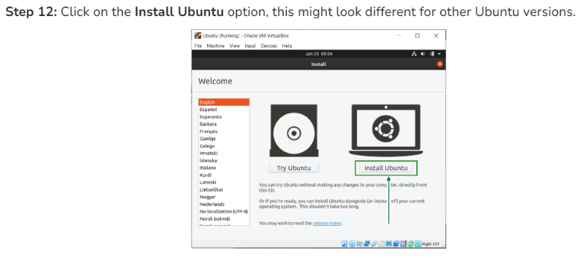

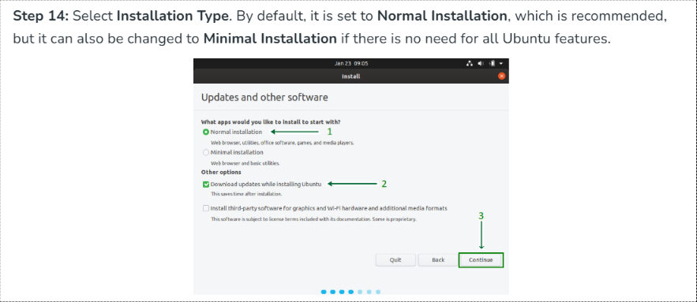

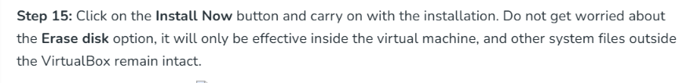







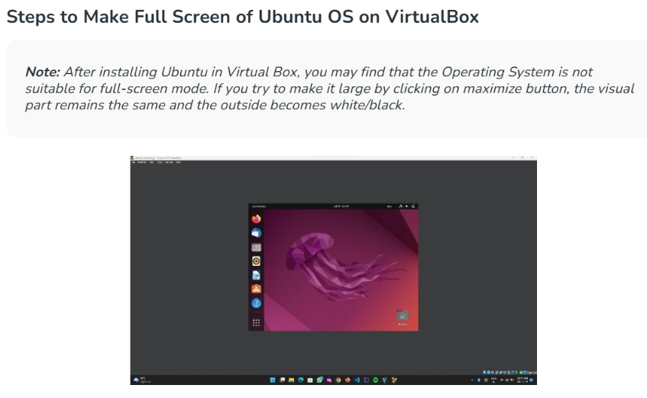

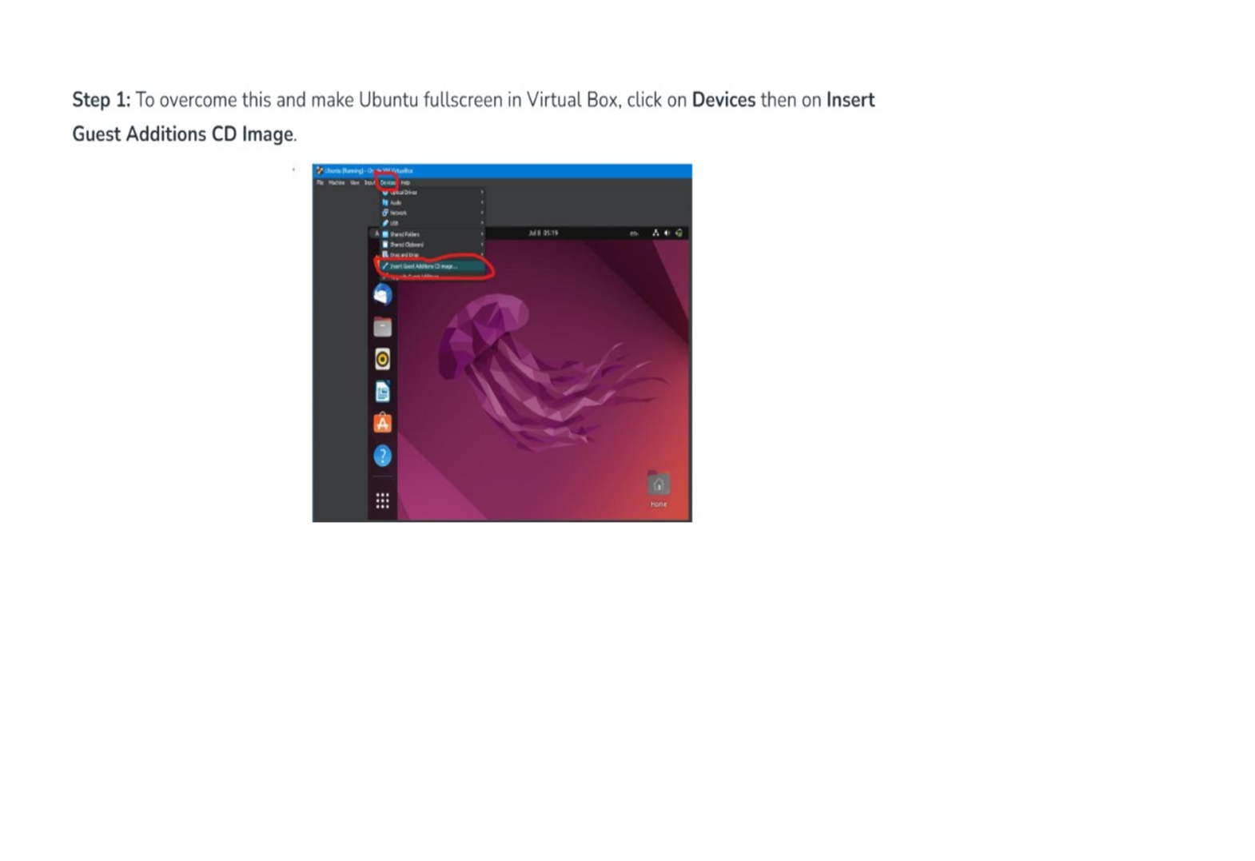

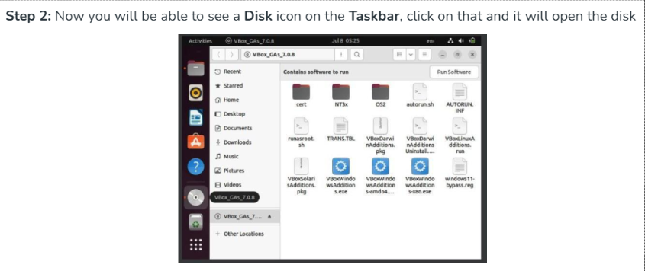

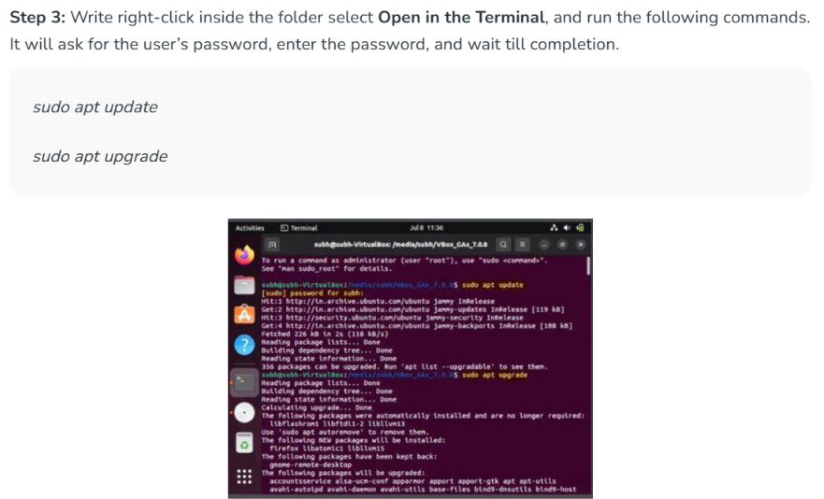

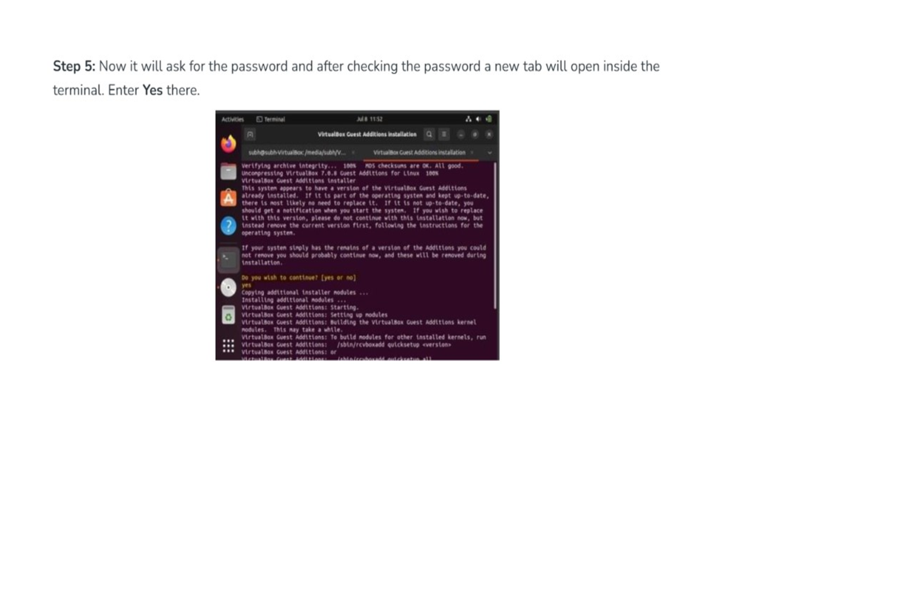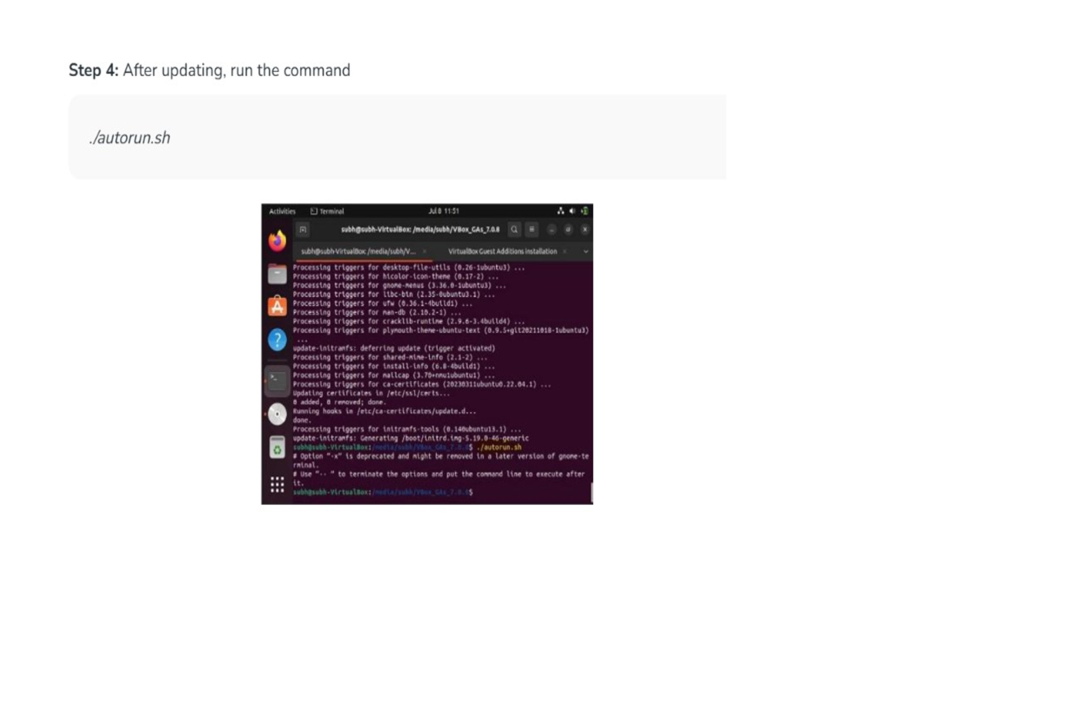

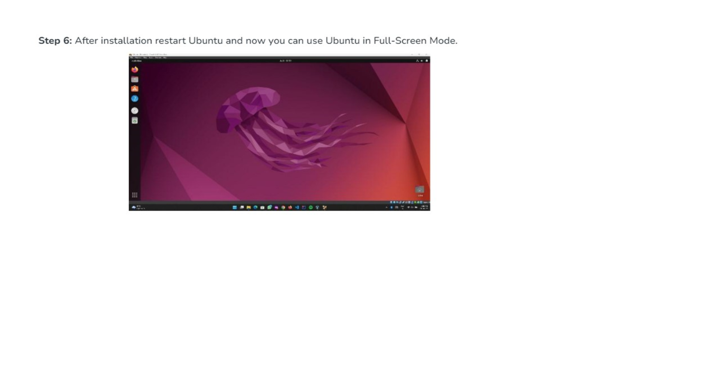

**EX.NO.2**

# Install a C compiler in the virtual machine created using virtual box and execute Simple C Programs

**Aim:**

To Install a C compiler in the virtual machine created using virtual box and

execute Simple Programs`

# PROCEDURE:

# Steps to run c program:

* 1. Terminal: gcc - - version - if gcc not recognized execute below command
  2. Sudo apt install build-essesntial
  3. Create c file:
  4. Touch hello.c
  5. gcc hello.c –o test
  6. ./test

# Type gcc - - version - if gcc not recognized execute below command

# Sudo apt install build-essential

# Create c file: Type touch first.c

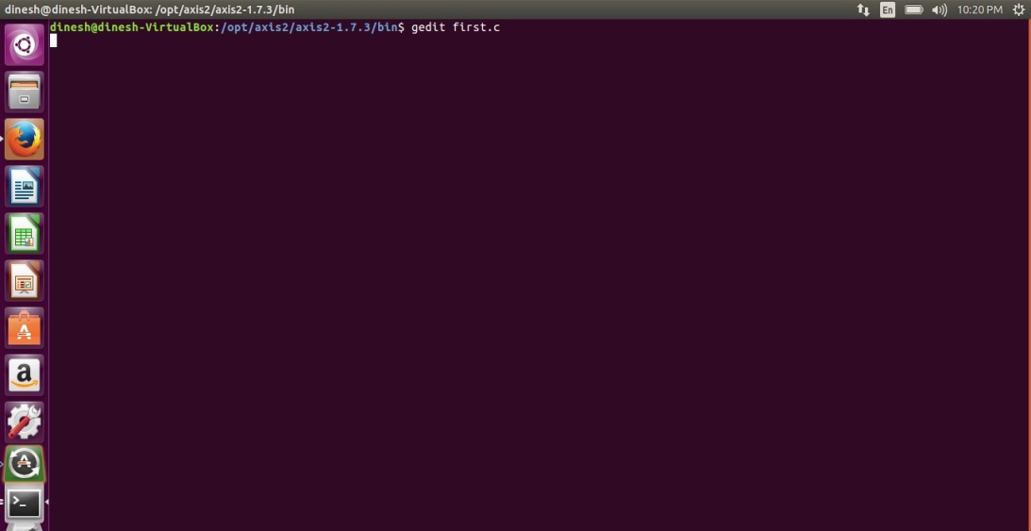

# Type the c program

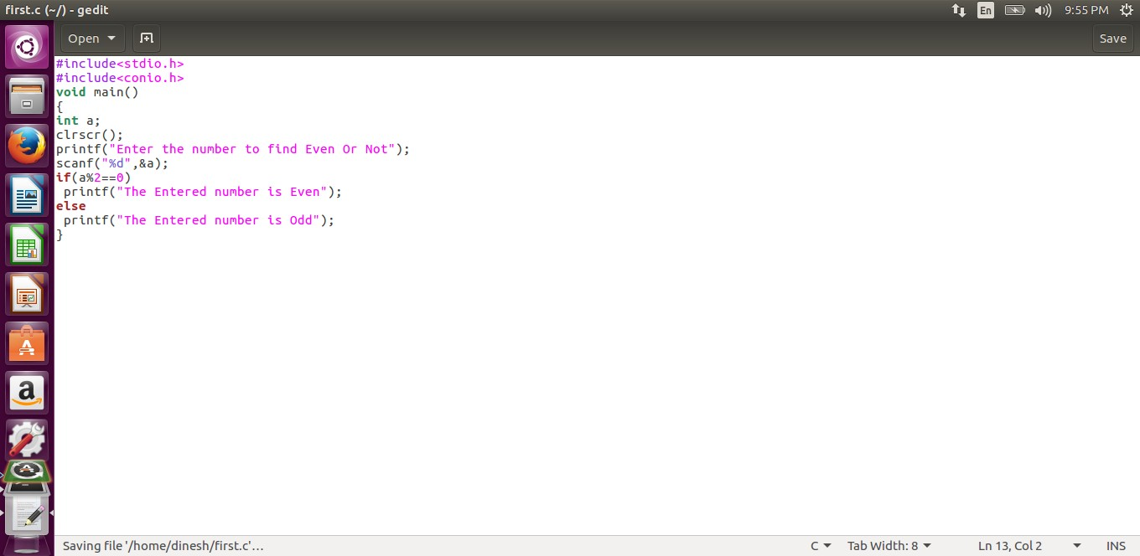

1. **Running the C program**

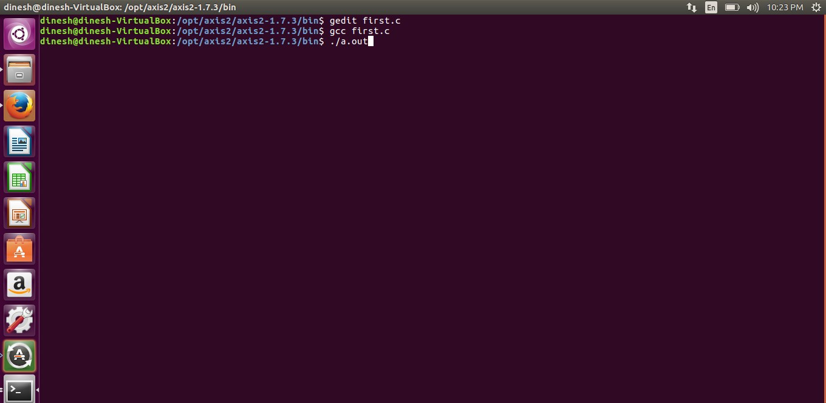

# Display the output:

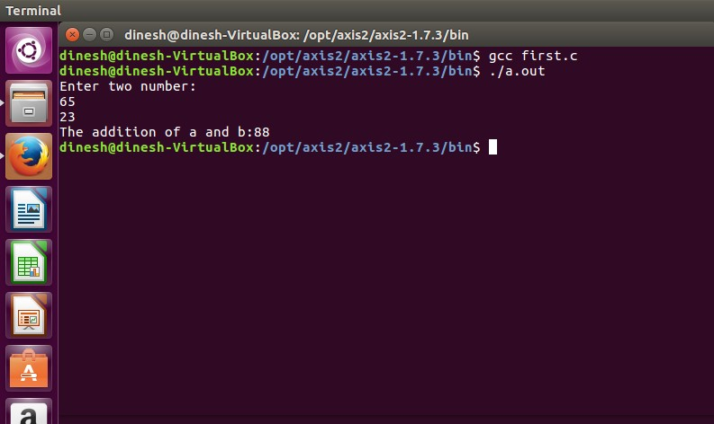

# RESULT:

Thus, the simple C programs executed successfully.

**EX NO.:3**

# Install Google App Engine. Create *hello world* app and other simple web applications using python/java.

# Step 1: Download the Google app engine using the following link:

# <https://google-app-engine.en.lo4d.com/windows>

# 

# Features of Google App Engine

# APIs: Access to over 60 Google Cloud APIs.

# Automatic scaling: Automatically scale applications up or down based on user traffic.

# Cloud Storage: Store data in Google’s cloud storage platform.

# Console: User-friendly dashboard with monitoring and logging features.

# Debugging: Debugging and profiling tools.

# DevOps: Continuous integration and deployment.

# Easy deployment: Quickly and easily deploy applications.

# Flexible Environment: Create custom environments for applications.

# Performance: High performance and low latency.

# Pricing: Flexible and affordable pricing options.

# Programming Flexibility: Ability to customize applications with custom code.

# SDK: Includes SDKs for Python, Java, Go and PHP.

# Security: Robust security features and access controls.

# Task Queues: Manage application tasks with queues.

# Versions: Create and manage multiple versions of applications.

Step 2: Click on google app engine to install

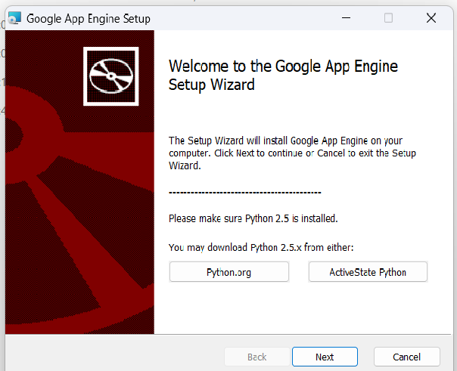

Step 3: in fig select Python.org 🡪 click on that automatically opens the

<https://www.python.org/downloads/> 🡪 come down and select Python 2.7.9

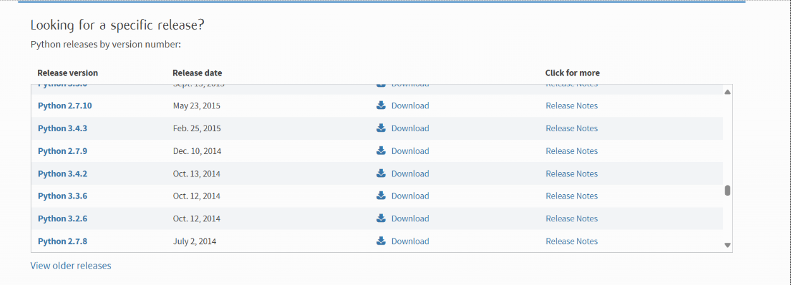

Select Python 2.7.9 click

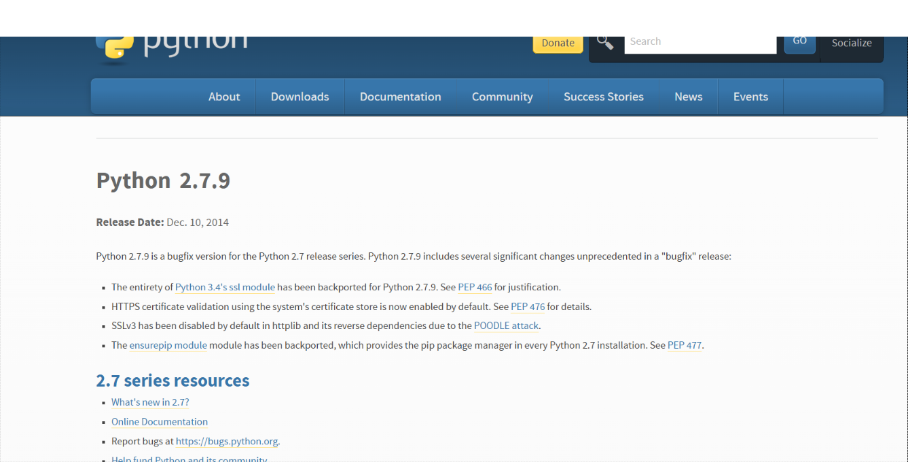

In files window select [Windows x86 MSI installer](https://www.python.org/ftp/python/2.7.9/python-2.7.9.msi)

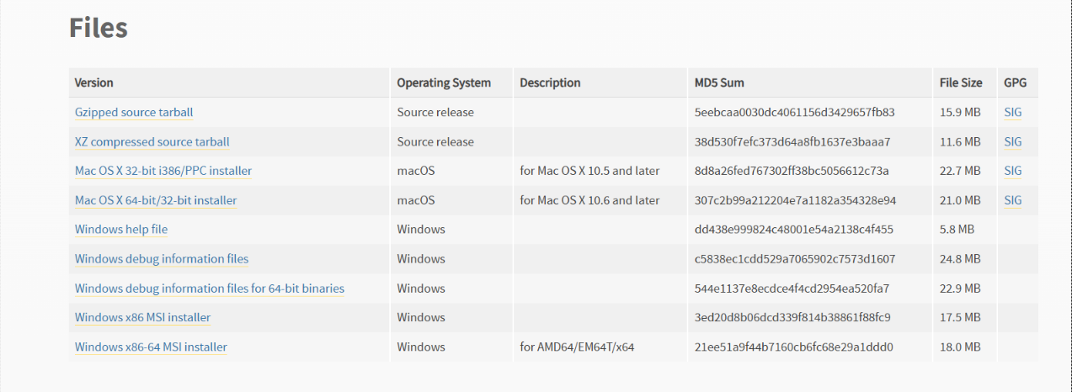

After clicking [Windows x86 MSI installer](https://www.python.org/ftp/python/2.7.9/python-2.7.9.msi) python 2.7.9 download starts after downloading click get below window

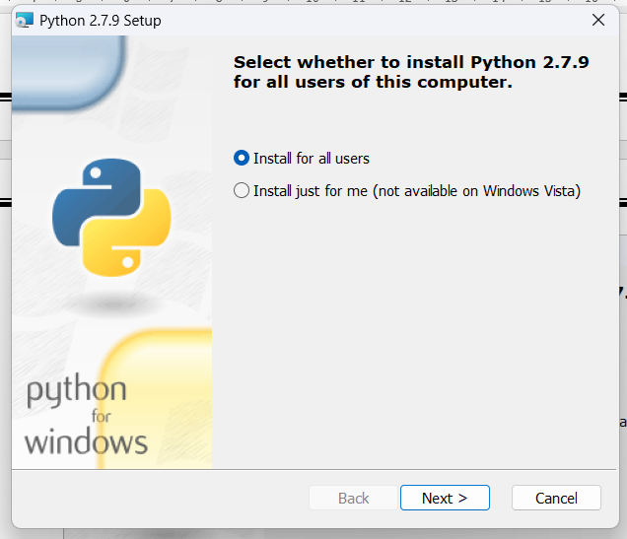

Click Next 🡪

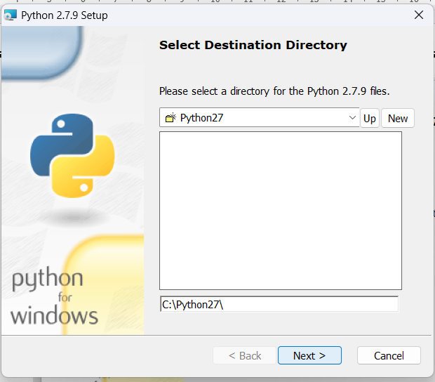

Next 🡪

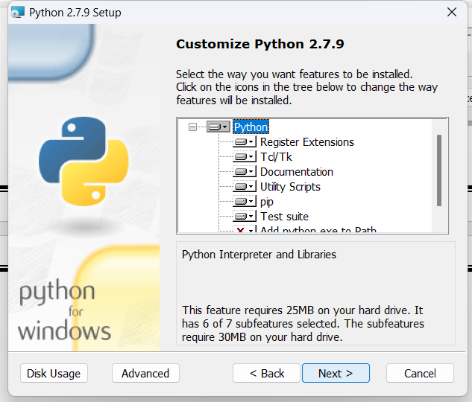

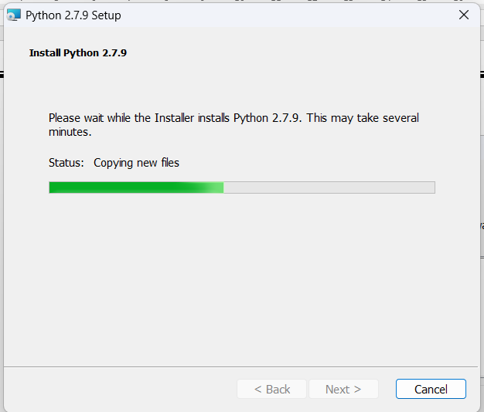

* finish

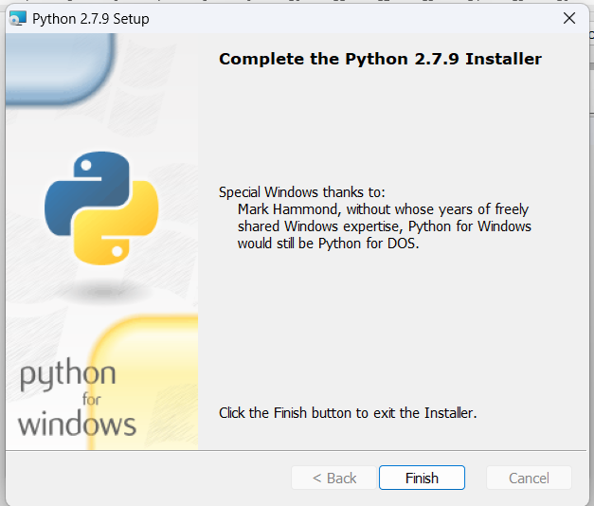

Step 4: install google app engine to click next

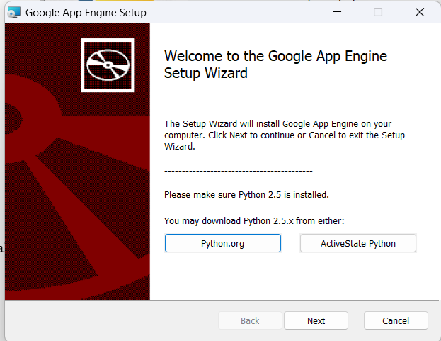

Click next🡪

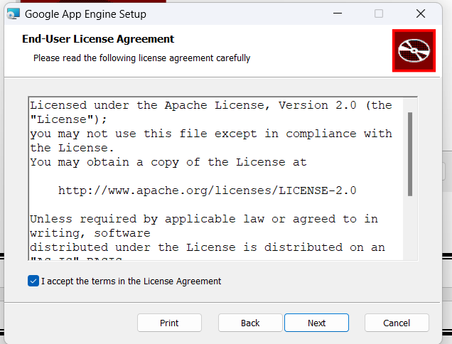

🡪Click next

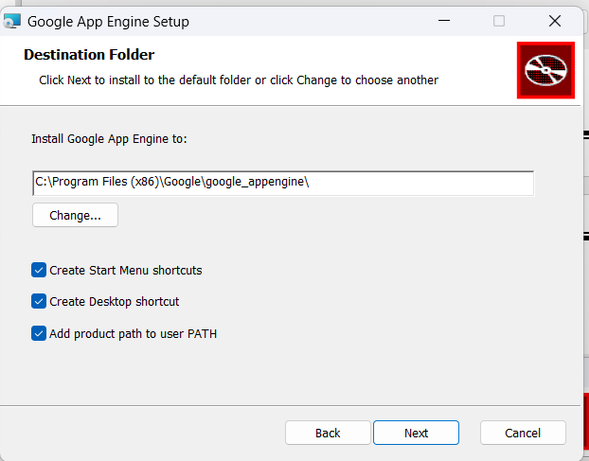

* click next

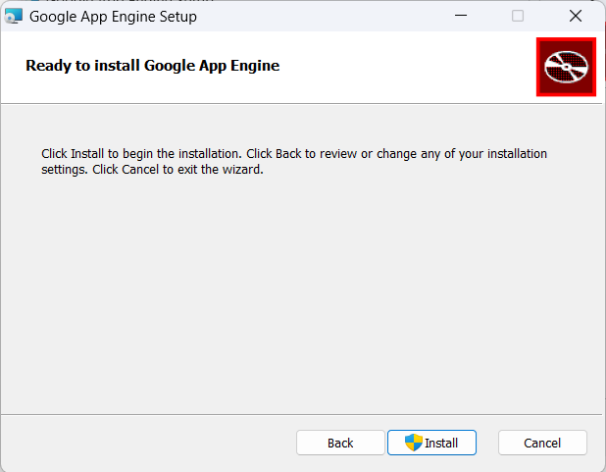

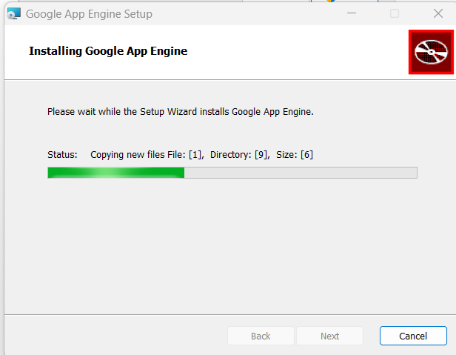

🡪click finish

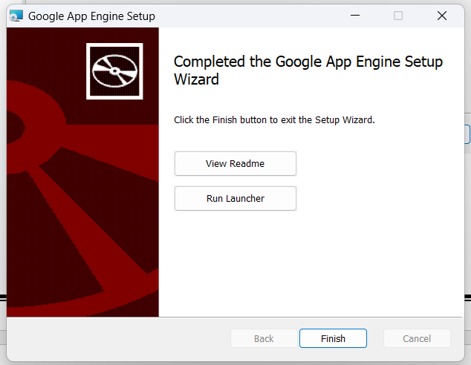

Step 5: After installation of google app engine 🡪click Google App Engine Launcher

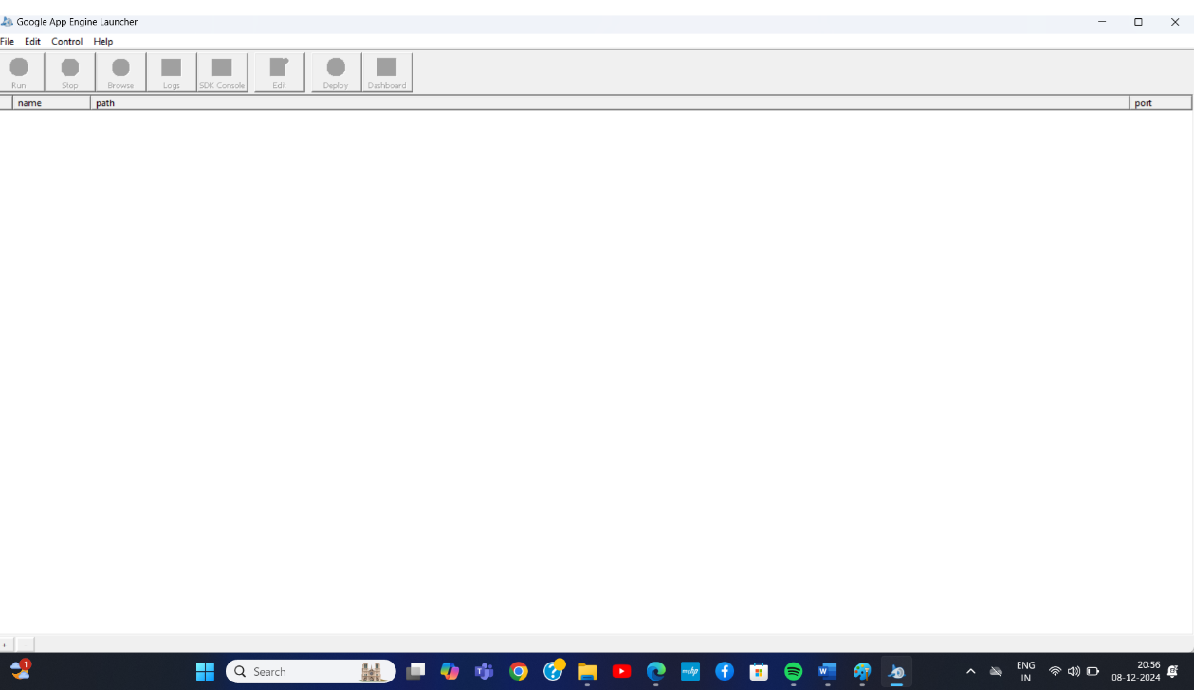

Step 6: in edit option 🡪 click preferences

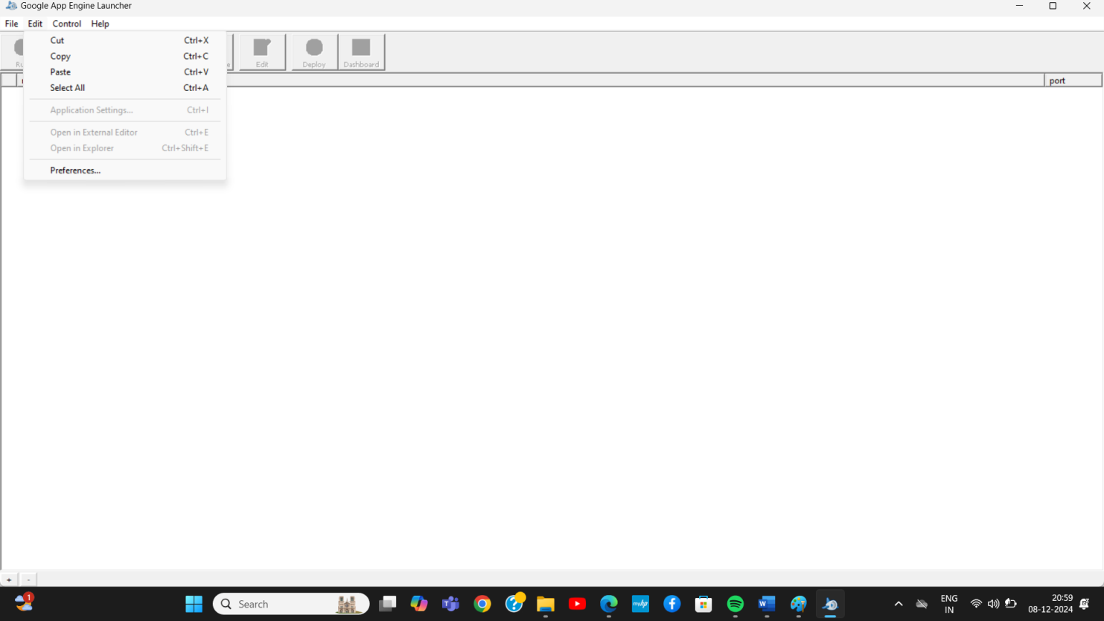

Step 7: set python path 🡪 C:\Python27\pythonw.exe

Set App engine path 🡪 C:\Program Files (x86)\Google\google_appengine 🡪 click ok.

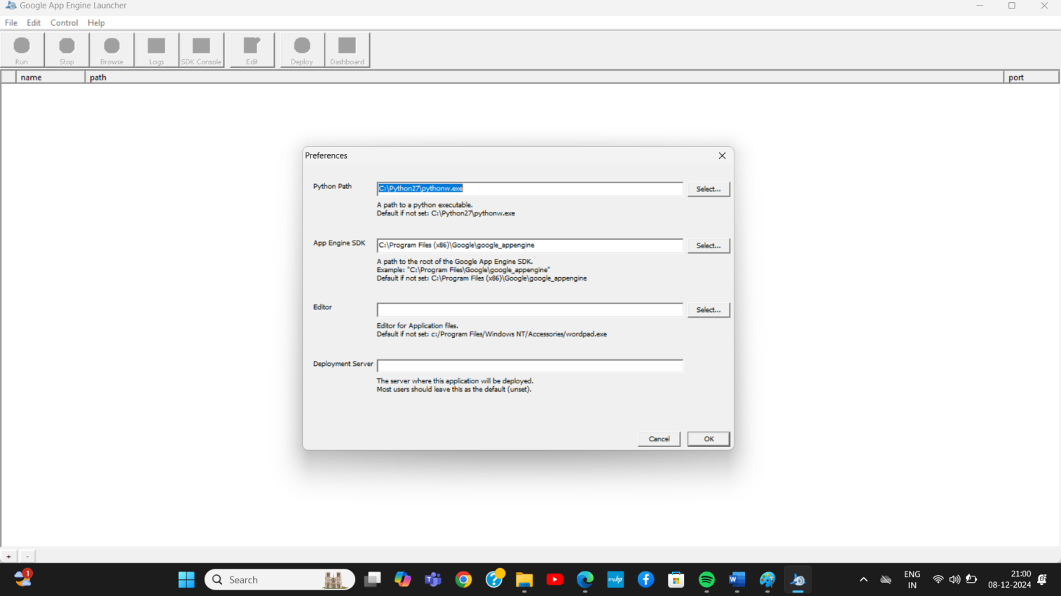

Step 8; Create empty folder on desktop app

Step 9: then go to google app engine and click file then select create new application

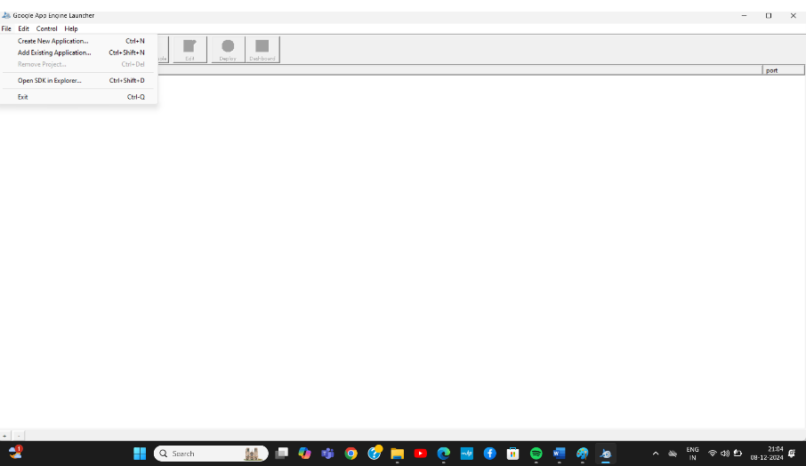

Step 10 : click create

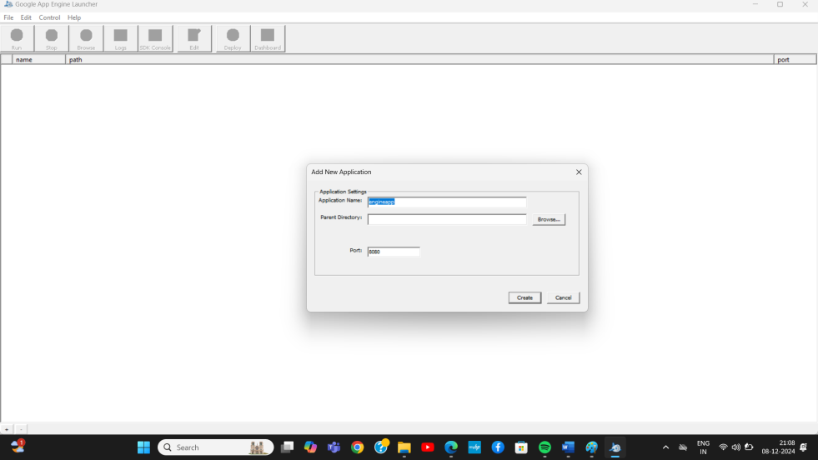

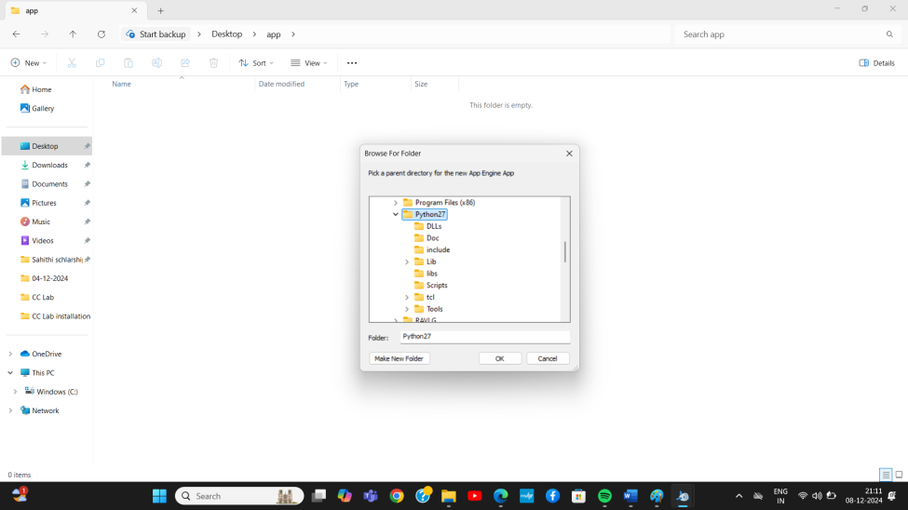

* Click create

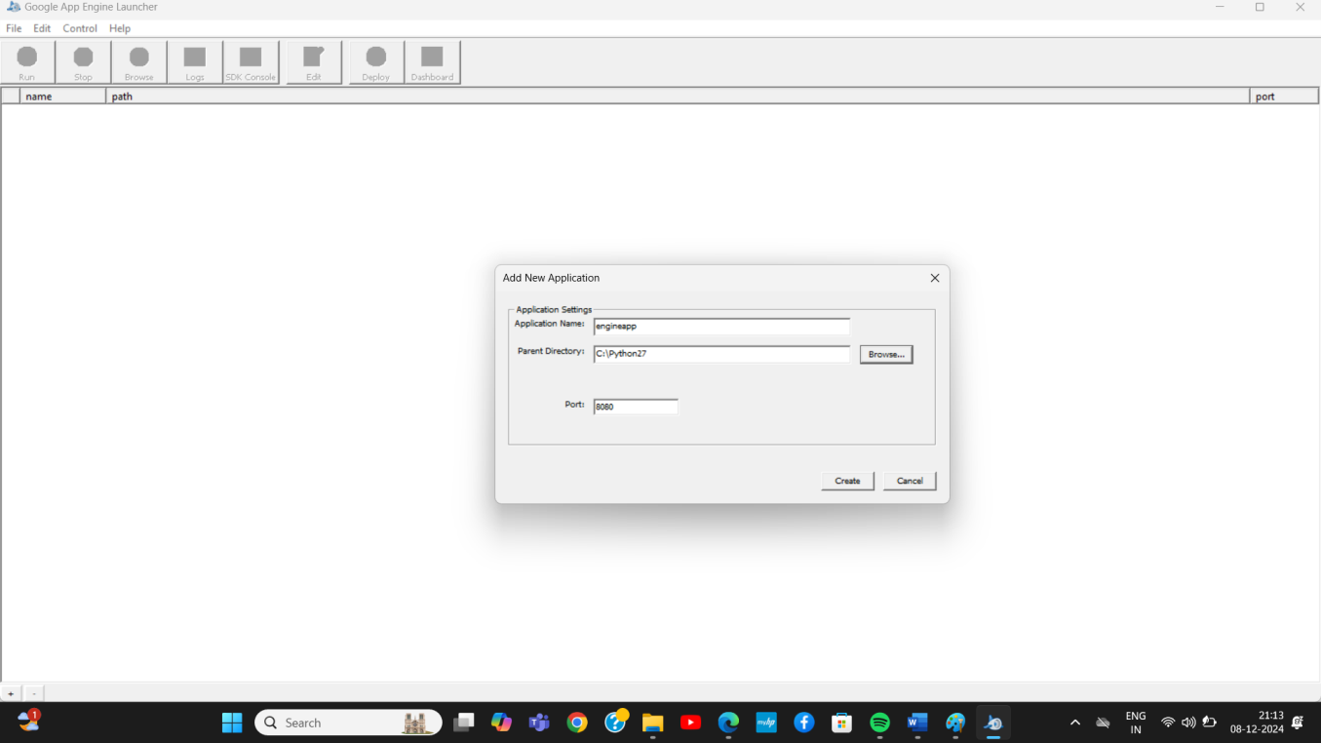

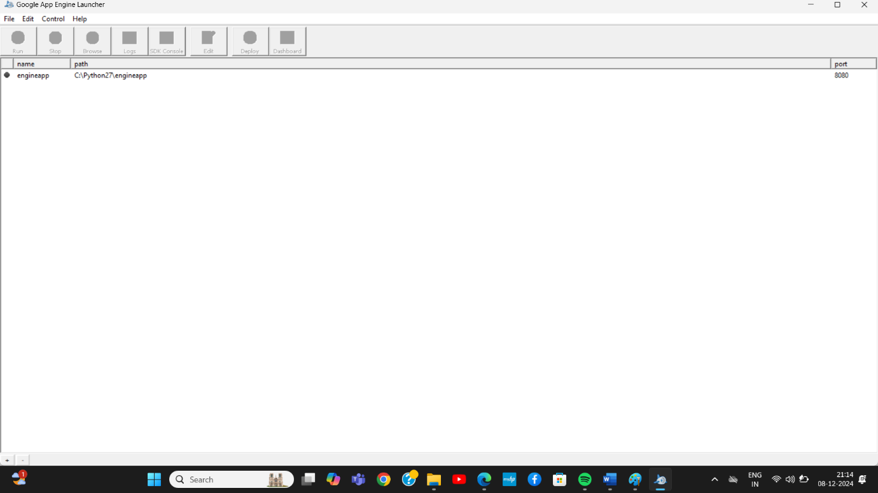

Select above project and click above run

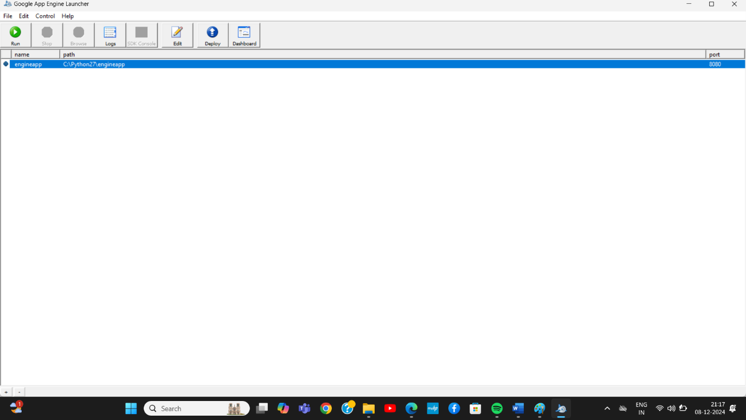

Step 11: open browser and type localhost:8080

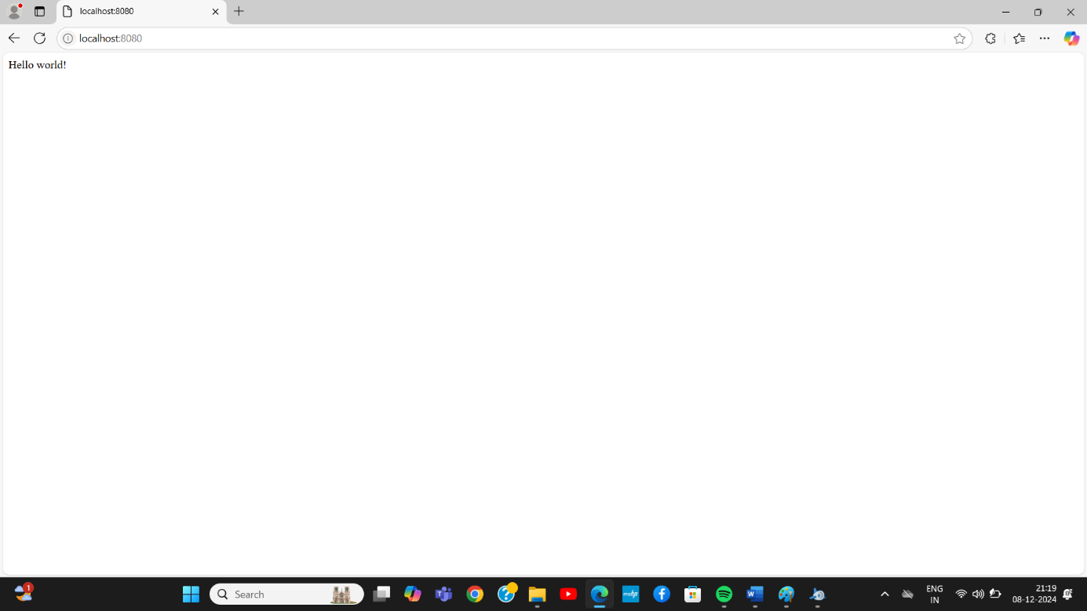

# Result:

Thus the simple application was created successfully

**EX.NO:4**

**Find a procedure to transfer the files from one virtual machine to another virtual machine.**

**Steps: Open ubuntu virtual machine and then click on devices 🡪 click on shared folders 🡪shared folder**

**settings**

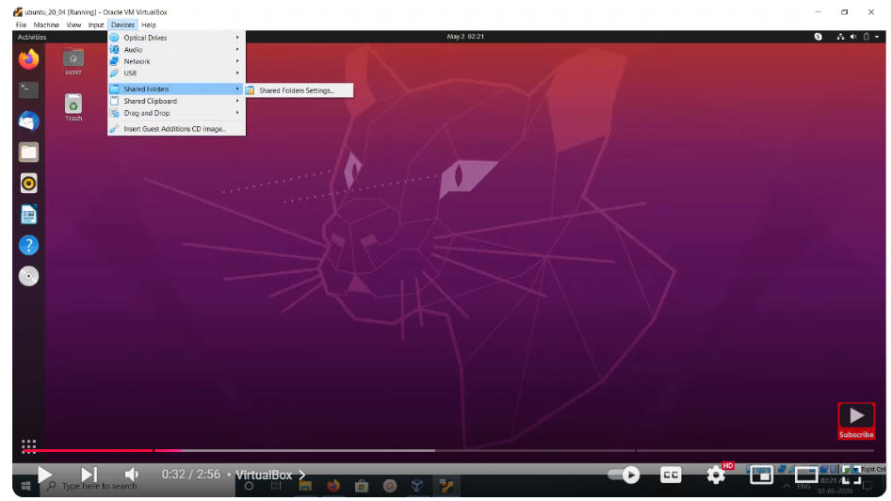

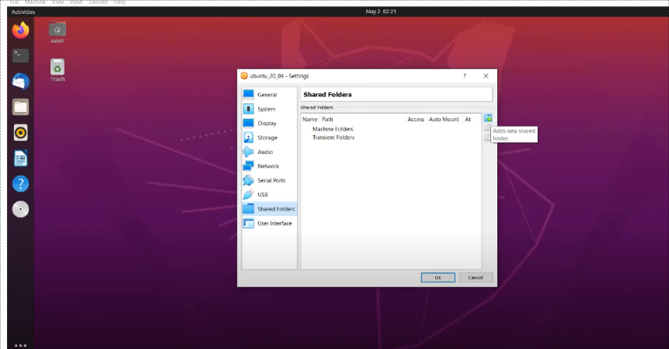

**🡪right side you fine one icon adds shared folder click on that __--> opens below window**

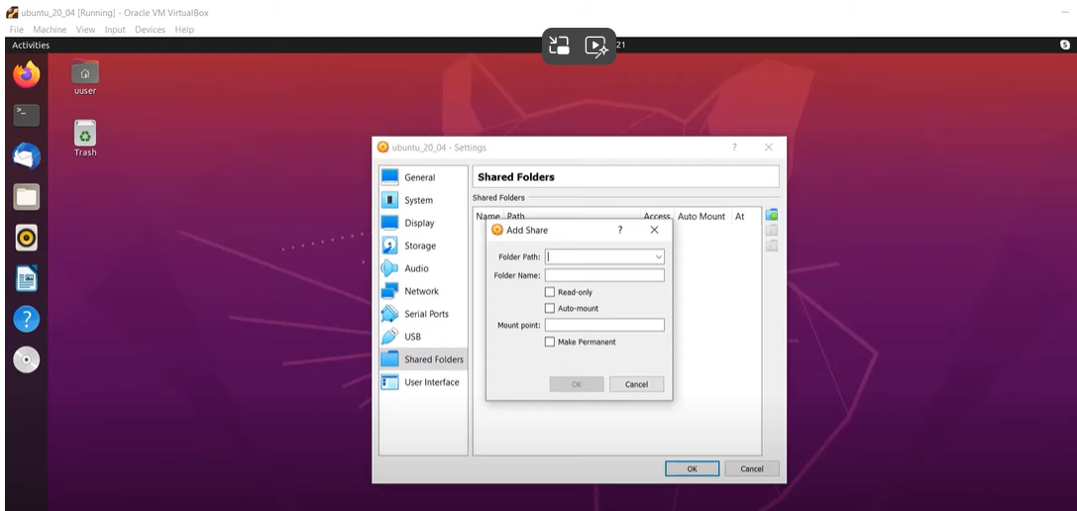

**_--> click on browse and then select folder from host machine you’re going to share with ubuntu virtual**

**Machine 🡪 select any folder and**

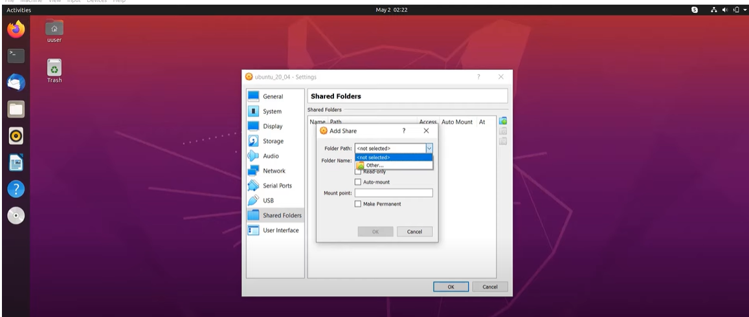

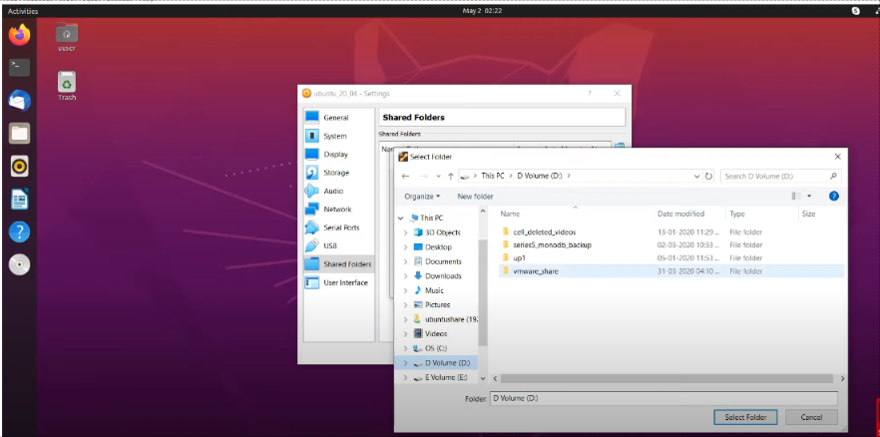

* **After select folder name 🡪 select auto mount option and mount point /mnt 🡪 click ok**

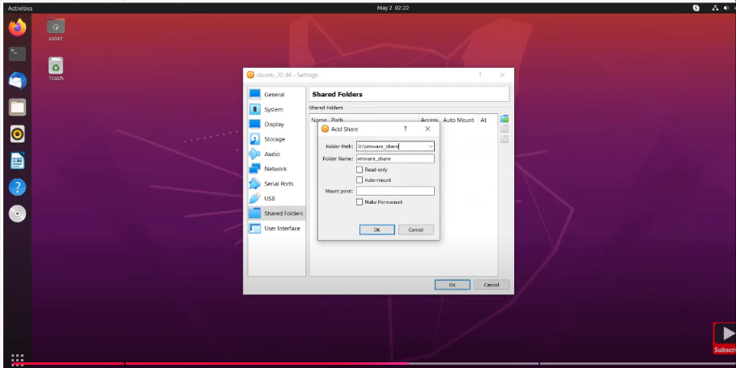

* **Click ok again**

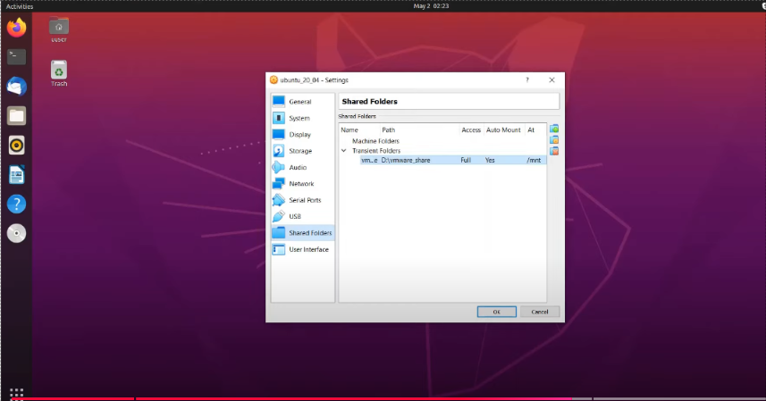

* **Now on ubuntu virtual machine click on file then click on other locations**

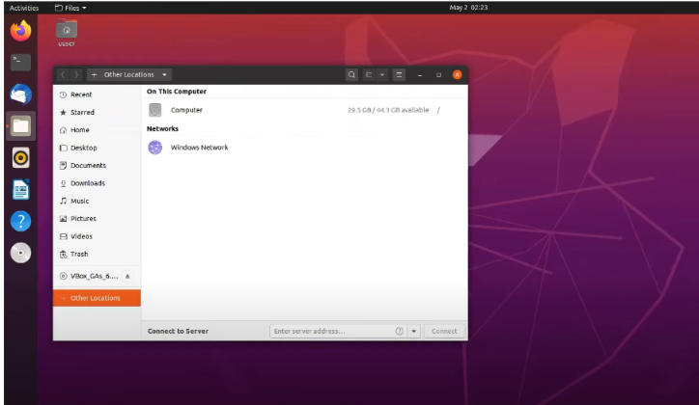

* **Click on computer**

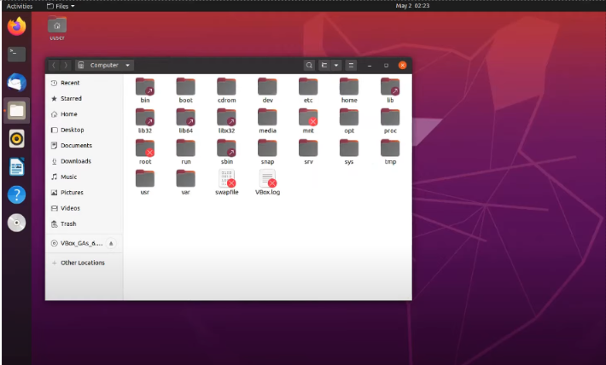

* **Above you can see the mnt folder 🡪 open to folder enter ubuntu login password**

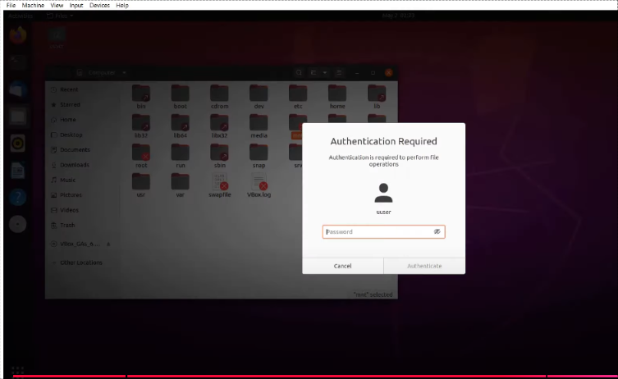

* **Now here you can see the files and folders from the shared folder.**

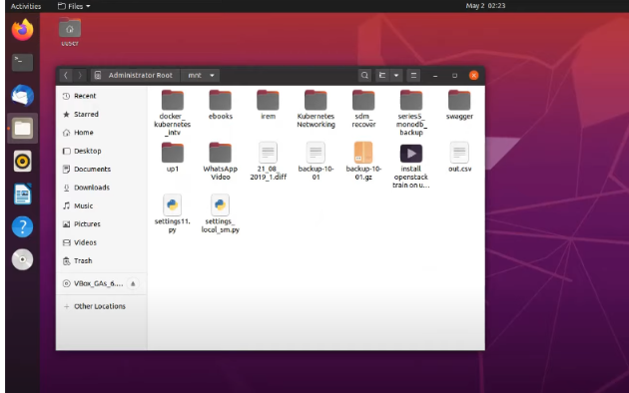

# Result:

# Thus, the folder or file shared between host and ubuntu VM was successfully completed.